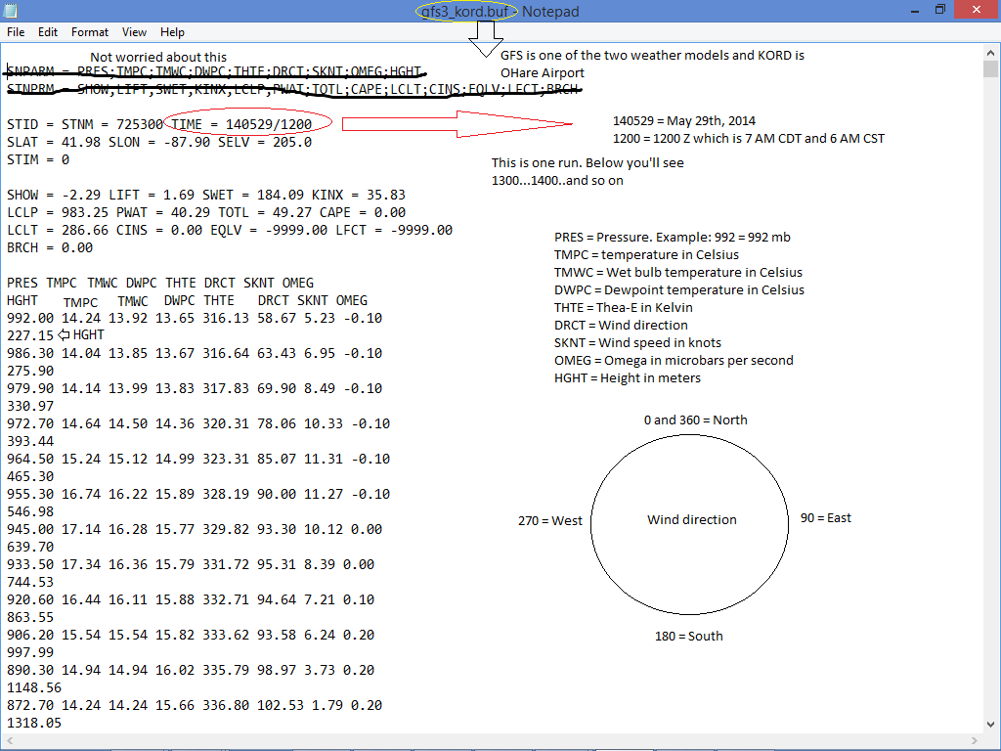

GFS is one of the two weather models and KORD is O’hare Airport

140529 =2014, MAY 29

1200 = 1200 Zulu which is 7am CDT and 6am CST

PRES = Pressure, example: 992 = 992 mb

TMPC = temperature in Celsius

TMPF = temperature in Celsius $( TMPF = ( 1.80 * TMPC ) + 32 )$

TMWC = wet bulb temperature in Celsius

DWPC = dewpoint temperature in Celsius

THTE = Thea-E in Kelvin

DRCT = wind direction

SKNT = wind speed in knots

OMEG = omega in microbars per second

HGHT = height in meters

NORTH is up and equals 0 or 360 degrees/SOUTH is up and equals 180 degrees

WEST is up and equals 270 degrees/EAST is up and equals 90 degrees

**CALCULATIONS:**

Rule of thumb: during the day clear skies = forecast warmer temperatures

**ON CLOUDS:**

clouds will lead to cooler temperatures; the more clouds the less likely it’ll be as warm as other sources are forecasting

at night, clear skies means cooler temperatures; clouds at night will allow the temperatures to be a bit warmer.

**RELATIVE HUMIDITY (RH):**

plays a role in cloud formation (equation on file for determining clouds)

$RH = \frac{VAPOR PRESSURE (VP)}{SATURATION VAPOR PRESSURE (SVP)}$ $* 100\%$

(multiply 100% for output but not for calculations if needed for anything else)

$VP = 6.112 * exp ( \frac{17.67 * DWPC}{243.50 + DWPC} )$

$SVP = 6.112 * exp ( \frac{17.67 * TMPC}{243.50 + TMPC} )$

**PRECIPITATION:**

average out the model output

relative humidity > 70% && OMEG = negative >>>> indicates rising motion

less negative omega = less of a chance of precipitation

**SNOW:**

Surface temp <35 F (1.7C)

Freezing level <1200 ft (366 m)

850 mb temp < 0 C

700 mb temp < -4 C

Temp < 0C from 1200 ft to 700 mb

Moisture from the surface to 700 mb (Temperature - dewpoint = dew point depression). Tdd > 10 means less moisture. Never negative.

Not all of these have to be in place for snow to occur, but the big ones are

moisture, surface temp, freezing level, and 850 mb temp.

**THUNDERSTORMS:**

Total Totals > 40

TT = (Temp 850 - Temp 500) + (Dewpoint 850 - Temp 500)

K Index >= 15

K Index = (Temp 850 - Temp 500) + (Dewpoint 850 - (Temp 700 - Dewpoint 700))

Lifted Index(LIFT on data): <0 = unstable environment

Sweat Index(SWET on data): >150 means better instability

Showalter Index(SHOW on data): < 0 = better instability

CIN must = 0 at some point in the day if CAPE is > 0 for a chance of thunderstorms. The more parameters above we have in the unstable environment, the better likelihood of severe weather